I. Installation Maintenance

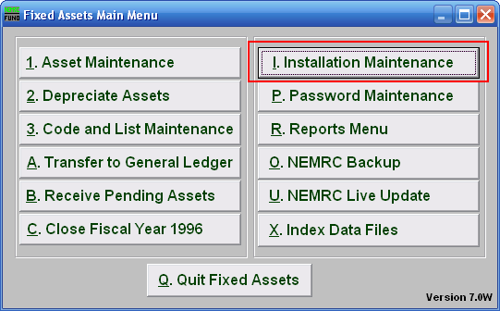
Click on “I. Installation Maintenance” from the Main Menu and the following window will appear:

Installation Maintenance

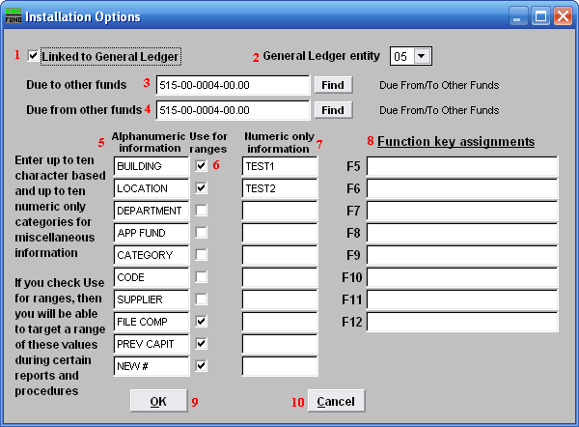
- Linked to General Ledger: Click on this box if Fixed Assets will be linked to the General Ledger.

- General Ledger entity: Enter in the General Ledger entity number or select from the drop down menu.

- Due to other funds: Enter in the General Ledger number or click on “Find” and select from the drop down menu.

- Due from other funds: Enter in the General Ledger number or click on “Find” and select from the drop down menu.

- Alphanumeric information: This is where the user may define the Miscellaneous fields. The fields that these will define are Alphanumeric.

- Use for ranges: Check the box next to each field definition to have it appear in the Miscellaneous tab for each report.

- Numeric only information: This is where the user may define the Miscellaneous fields. The fields that these will define are Numeric.

- Function key assignments: These are used to set shortcuts for common phrases for easy use, and to save you from having to retype something multiple times.
When a value is assigned from the point of the cursor placement the function key with the assignment can be used to populate fields. Each of these fields are linked to the “Function key” that is to its left. This means that when you hit the “F_” key on the keyboard, the text you entered for that “Function key” will appear.

- OK: Click “OK” to save changes and return to the previous screen.

- Cancel: Click “Cancel” to cancel and return to the previous screen.

